# Elicitation Execution

# Observation

Based on the elicitation plan

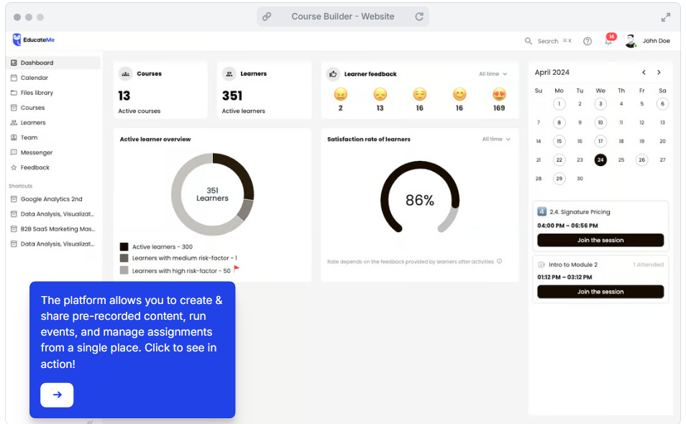*Figure 1.0 Screenshot of EducateMe website*

Overview:

This observation was done to research the interface of a competitor Learning Analytics System. This was targeted to find possible dissatisfiers that, if not present or poorly executed, could detract from the User Experience.

## User Interface Design

Navigation & Layout: The dashboard is clean and neat; however, much information might be overwhelming for new users. Providing options for customizable dashboards, where users can hide or change the order of widgets, could potentially resolve this dissatisfaction.

Data Visualization: The system uses simple circular and bar graphs to present the learner's feedback and satisfaction rate. These will work but lack interactivity and customizability that might not be satisfactory for the advanced users. Employing more dynamic and customizable visualizations, like interactive charts and drill-down functionality, makes a difference in the product.

The left-hand shortcuts area is good for easy navigation, although it sometimes becomes a bit too cluttered. A collapsible, or user-customizable shortcut area, would help in terms of usability and satisfaction.

## Functionality

Learner Feedback: The feedback system seems to rely mostly on simple emoticons. This is rather straightforward but doesn't really give educators that deep insight some might want from such feedback. Being able to provide more granular methods of feedback and being able to tie those directly to course elements can be valuable.

Active Learner Overview: The overview provides an insight into active learners and very little about learner progress or performance trends. Further features of tracking the progress of learners over time, flagging learners who may be struggling, suggesting intervention may be some likely dissatisfiers.

Scheduling & Events: Integration of the calendar works, but the interface feels more about upcoming sessions, without past performance indicators or future deadlines. Such a module integrated with reminders, past event summaries, and integration with external calendars may help enhance user experiences, especially for those managing multiple courses.

## Performance Indicators:

Learner Feedback and Satisfaction Rate: The system only shows the all-time data for feedback and satisfaction, which cannot be used meaningfully. It would be very helpful if filtering could be enabled for these metrics by course, time period, or learner group.

Tooltips and Guidance: There is a tooltip at the bottom left of the system that generally describes the use of the platform. This is useful, but perhaps the tooltip could be context-sensitive, offering guidance about the particular section one may be working in.

## Recommendations:

Customization: More from within the dashboard could be made customizable to let users tailor the experience more.

Interactivity: Data visualizations could be made more interactive to get finer insight.

Feedback mechanisms: Increase the number of feedback options to include more detailed and actionable responses.

Learner tracking: Develop functionality for detailed tracking of learner progress, intervention suggestions, and customized performance metrics.

# Interview

**Participant Profile:**

* **Gender:** Male
* **Occupation:** Student at a private local university, part-time developer

#### **1. Project Vision and Scope Understanding**

* **Question:** After reviewing the vision and scope of the project, how well do you understand the project objectives? Please rate from 1 to 5.
* **Response:** *Rating: 4/5*

#### **2. Expected Functionalities (Satisfier)**

* **Question:** What specific functionalities do you expect the system to provide?
* **Response:** As a student, I expect the system to provide analytic reports that are visually represented through graphs or charts.

#### **3. User Interface Requirements (Satisfier)**

* **Question:** Do you have specific requirements for the system’s user interface?
* **Response:** The system should have a user-friendly navigation bar that allows for easy navigation. For example, the navigation bar should be intuitive and accessible.

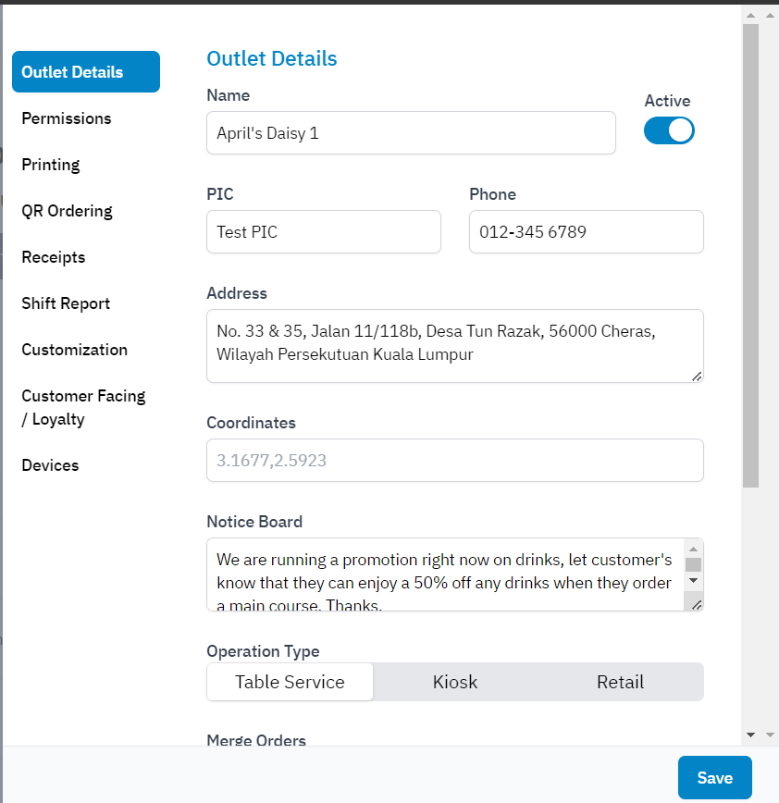

*Figure 2.0 Example of good navigation and layout provide by interviewer*

#### **4. Critical Features for Success (Delighter)**

* **Question:** What is the critical feature that the system must have to be successful?
* **Response:** The system must be accessible on multiple devices and provide accurate data of the reports to ensure success. Other than that, Real-time chat may include also when the lecturer found the student that seriously lack behind lecturer able to conduct the student directly via the chat box.

#### **5. Necessity of Single Sign-On (SSO) (Dissatisfier)**

* **Question:** Do you think a Single Sign-On (SSO) is necessary for the system?
* **Response:** Yes, SSO is absolutely necessary.

### **Interview Summary (Developer Perspective)**

**Participant Profile:**

* **Gender:** Male
* **Occupation:** Student at a private local university, part-time developer

#### **1. Project Vision, Scope, and Goals Understanding**

* **Question:** If you were the developer of this project, would you be able to understand the project objectives by reviewing the vision, scope, and goals? Please rate from 1 to 100%.
* **Response:** *Rating: 80%*

#### **2. Anticipated Challenges (For Future Negotiation)**

* **Question:** What challenges do you foresee while implementing the features?
* **Response:**
  + Implementing the system across multiple devices could present challenges due to the differences in operating systems.
  + Ensuring the accuracy of data could be another challenge, as human error in coding can result in miscalculations or interaction issues. This will require extensive testing and trial-and-error.

#### **3. Enhancing User Engagement (Delighter)**

* **Question:** What features could be implemented to enhance user engagement within the Learning Analytics System (LAS)?
* **Response:** To increase user engagement, incorporating an attractive user interface with elements such as animations could be beneficial.

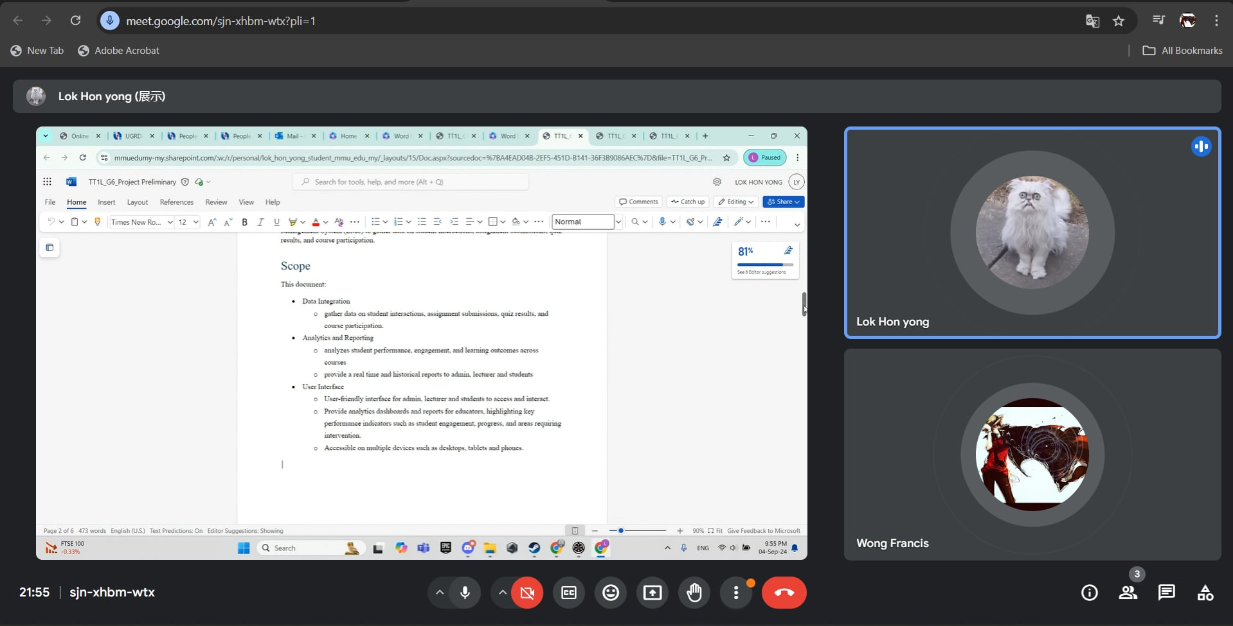*Figure 3.0 Screenshot of Lok Hon Yong interviewing*